INDIVIDUALIZED PLAN AND EMERGENCY PROCEDURES

FOR A CHILD WITH AN ANAPHYLACTIC ALLERGY

Photo of Child
(recommended)
Child’s Name:
Child's Date of Birth (dd/mm/yyyy):
List of allergen(s):

Health Card Number:
Asthma: ☐Yes (higher risk of severe reaction) ☐No
Location of medication storage:

Epinephrine auto-injector (EpiPen/AllerJECT) brand name:
Epinephrine auto-injector (EpiPen/AllerJECT) expiry date (dd/mm/yyyy):
Other emergency medications:

CHILD’S SPECIFIC SIGNS AND SYMPTOMS OF A NON-LIFE THREATENING ANAPHYLACTIC REACTION: (specific to the child, e.g. wheezing and itchy skin)  Please circle your child’s specific symptoms:  - Flush face, hives, swelling or itching lips, tongue or eyes  - Vomiting, nausea, diarrhea, stomach pains  - Tightness in throat, mouth or chest  - Dizziness, unsteadiness, sudden fatigue, rapid heartbeat  - Difficulty breathing or swallowing, wheezing coughing or choking  - Loss of consciousness  Other Possible Symptoms: | CHILD’S SPECIFIC SIGNS AND SYMPTOMS OF A LIFE THREATENING ANAPHYLACTIC REACTION: (specific to the child, e.g. inability to breathe, sweating)  Please circle your child’s specific symptoms:  - Flush face, hives, swelling or itching lips, tongue or eyes  - Vomiting, nausea, diarrhea, stomach pains  - Tightness in throat, mouth or chest  - Dizziness, unsteadiness, sudden fatigue, rapid heartbeat  - Difficulty breathing or swallowing, wheezing coughing or choking  - Loss of consciousness  Other Possible Symptoms:
DESCRIPTION OF PROCEDURE TO FOLLOW IF CHILD HAS A NON-LIFE-THREATENING ANAPHYLACTIC REACTION: | DESCRIPTION OF PROCEDURE TO FOLLOW IF CHILD HAS A LIFE-THREATENING ANAPHYLACTIC REACTION:
STEPS TO REDUCE RISK OF EXPOSURE TO ALLERGEN: (e.g. nut-free environment)

ADDITIONAL NOTES (if applicable): (e.g. use of other emergency allergy medication(s) to implement the emergency procedures)

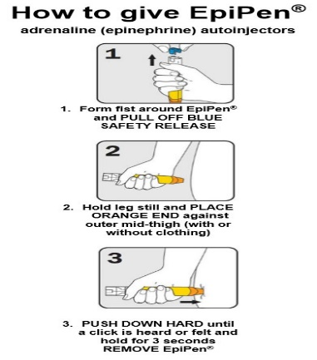
EMERGENCY PLAN
- Remove EpiPen from case
- Pull off coloured safety cap, BLUE to the sky, ORANGE to the thigh
- Firmly hold inner thigh
- Jab black tip into the thigh, even through clothing (you should heat a “CLICK”)
- Firmly hold EpiPen in place and wait 10 seconds before removing unit
- Gently massage area
- Call for assistance
- Call 911 and report anaphylactic shock
- Contact Parent/Guardian or emergency contact
- Stay with child until help arrives
- Give EpiPen to paramedics
The staff or the Supervisor will accompany the child to the hospital if the parents are unable to arrive at the childcare centre in time.

Parental Statement
I ______________________________________ (parent/guardian) hereby give consent to any person with training on this plan at the child care centre to administer my child’s epinephrine epi-pen or auto-injector and/or asthma medication and to follow the procedures set out in my child’s Individualized Anaphylaxis Plan and Emergency Procedures.

Parent/Guardian initials: ________

EMERGENCY CONTACT INFORMATION
Contact Name | Relationship to Child | Primary Phone Number | Additional Phone Number

HEALTHCARE PROFESSIONAL CONTACT INFORMATION:
Contact Name | Primary Contact Number

SIGNATURE OF PARENT/GUARDIAN:
Print name: | Relationship to Child:
Parent Signature:  X | Date:
Childcare Representative:  X | Date:

