.

Welcome to the TTELC Toddler Room!

At TTELC, our dedicated staff strive to establish a toddler classroom that offers care to your child in a safe, healthy, and nurturing environment. We have a phone line directly in the classroom so parents can call during the day and ask how their child is doing, and staff can also call the parent if they have any questions or concerns. TTELC also uses a web-based parent communication tool, Fastoche, which allows the staff to send email updates about your child’s day along with photos.

**A minimum of 2 days is required to attend in the Toddler Room**

An update to date immunization record or a Statement of Medical Exemption Form or a Statement of Conscious or Religious Beliefs Form is required.

TEACHING STAFF – CHILD RATIOS

TTELC Toddler classrooms are limited in group size from 10 to 15 children, depending on location, and the teaching staff: child ratios of 1:5 is followed.  Whether a teacher works alone with a group of children or the teaching team works in collaboration, the environment is designed to support children’s positive learning and development across all areas.

MENU

A 4-week rotating menu can be viewed on our website and is displayed daily on Fastoche. TTELC follows the recommendations of the Canada’s Food Guide and offers a variety of nutritiously balanced meals and snacks as we believe that nutrition is vital to a child’s health, growth and development. Children in attendance will receive a morning snack, lunch and an afternoon snack. Each classroom is provided with an open snack and water which is readily available to the children throughout the day.

Please be aware that TTELC is a nut aware environment and that there will be no peanuts, tree nuts, or products that may contain nuts brought into our centre.

CURRICULUM GOALS

The experiences children at TTELC are provided with will have a tremendous positive impact on their development and may set the tone for future learning. Our goal at TTELC is to stay current on research in child development so that we are able to build a foundation for each child that lasts a lifetime. Our toddler programs implement the pedagogical approach “How Dow Learning Happen”? as mandated by the CCEYA. This highly researched document provides a foundation for educators to provide a safe and simulating environment. The curriculum in the toddler programs focuses on being responsive to children’s interests to create meaningful learning experiences.

**Children will get messy!**   In order to maximize children’s potential, in developing skills, children need to engage in hands‐on activities that utilize their senses.  All of the developmental changes that occur during the toddler years-increased language, budding independence and beginning awareness of peers

must be considered when developing a program.  Sometimes even the most carefully planned days need to be adjusted to meet an individual child’s reactions and needs.  Toddlers find consistent routines to be comforting and change in established routines to be unsettling.  Teachers want to work closely with every parent to minimize toddler frustrations and optimize learning.

Our classrooms are set up to create an environment that is rich with learning opportunities, nurturing and developmentally appropriate. The following goals are incorporated into the toddler programs:

* Foster self help skills to create a feeling of confidence and independence
* Provide classroom areas, materials and activities at the child’s level that supports and enhances their development, where children can discover and explore, both indoors and outdoors
* Provide care in small groups when teacher-child ratios allow to provide children with more personal attention, prevent over/under stimulation and maintain a more relaxed environment
* Provide a warm, nurturing and flexible environment where expectations are clear and respect is established

CLOTHING & SUPPLIES

Each child will have his or her own personal cubby space for belongings. Please label all items with your child’s name. Items to supply your child with while at TTELC are:

* Disposable diapers/cloth diapers/wipes
* Spill proof cup
* Inside shoes
* Sleep/rest time blanket (blanket will be sent home on Fridays to be laundered)
* Complete change of clothes
* Proper attire for the outdoor elements as we are outside for 1 hour in the morning and 1 hour in the afternoon

In order to maintain a healthy environment for the staff and children, soiled clothes/cloth diapers are immediately placed in a plastic bag (without rinsing) and sent home that day for laundering.

TODDLER DEVELOPMENT

At TTELC children in the toddler room are learning to:

* Drink from a lidless cup
* Sleep on a cot
* Self-feed with a spoon or fork, sit well in a chair
* Develop fine motor skills and refine gross motor skills-balance/coordination
* Manipulate and gain an understanding of books
* Express independence
* Enter beginning stages of cooperative play (cooperative play involves children playing and working with others towards a common goal or purpose)

OUTDOOR PLAY

Under the CCEYA, children in the toddler program are required to participate in outdoor play for a minimum of two (2) hours per day, one (1) hour in the morning and one (1) hour in the afternoon (weather permitting). Since we do not have additional staff to supervise children indoors, all children in attendance must be well enough to engage in outdoor play. Please ensure that your child is dressed appropriately for the season.

HEALTH

Personal cribs, separate areas for changing and feeding, ensure that the children will have clean playing, eating and sleeping spaces. Toys and play areas in the room are sanitized on a daily basis or as needed. Staff will carry out daily health checks as well as document in Fastoche children who are sick and all accidents/incidents.

The toddler years are marked by so much growth and change that we want to stress the importance of daily communications between parents and teachers.  Please feel free to discuss with us any concerns and we look forward to a fun filled experience together.



**For Office Use Only**

Date of Admission:

Date of Discharge:

**Age Group Placement at Time of Enrolment:** □ Infant □Toddler □ Preschool □School Age

Child Information

|  |  |
| --- | --- |
| **Full Legal Name:** | **Date of Birth (dd/mm/yyyy):** |
| **Home Address:** | |
| **Child’s Health Card Number:** | |
| **Doctor’s Name, Address and Phone Number:** | |

Parent/Guardian Information

|  |  |
| --- | --- |
| **Full Legal Name:** | **Relationship to Child:** |
| **Primary Phone Number:** | **Email address:** |
| **Place and Address of Employment:** | **Work Phone Number:** |
| **Home Address:**  □ Same as Child | |

|  |  |
| --- | --- |
| **Full Legal Name:** | **Relationship to Child:** |
| **Primary Phone Number:** | **Email address:** |
| **Place and Address of Employment:** | **Employment Phone Number:** |
| **Home Address:**  □ Same as Child | |

Emergency Contacts

In the event of an emergency, if a parent/guardian cannot be reached, the following individual(s) may be contacted. Please list in order of preference.

|  |  |
| --- | --- |
| Emergency Contact #1 | Emergency Contact #2 |
| Full Legal Name:  Primary Phone Number:  Alternate Phone Number:  □ Authorized to pick-up child | Full Legal Name:  Primary Phone Number:  Alternate Phone Number:  □ Authorized to pick-up child |

Pick-Up Authorization

The following additional individuals are authorized to pick up (Photo ID will be required to confirm identify before the child will be released. We will not release a child from TTELC to anyone under the age of 18 years.):

|  |  |
| --- | --- |
| Full Legal Name | Primary Phone |
|  |  |
|  |  |
|  |  |

Custody Arrangements (if applicable)

Are there custody arrangements pertaining to legal right of access to your child? □ YES □ NO

If YES, please provide a copy of the appropriate legal documentation (e.g., court order).

Name(s) of custodial parent(s): ________________________________________________________________________

Name(s) of individuals prohibited from accessing/picking up your child: ________________________________________

Health Information

If your child has had any history of communicable diseases (e.g., chicken pox, measles), please list them below:

Does your child have any medical need(s) that requires additional support (e.g., Diabetes, Asthma)?

□ YES □ NO

If yes, an individualized plan for children with medical needs must be developed between the parent and TTELC prior to your child’s first day of care.

Immunization Records

Please provide a copy of your child’s immunization record (yellow card) to TTELC prior to your child’s first day of care.

If you have chosen not to immunize your child, a Statement of Medical Exemption form or a Statement of Conscious or Religious Belief form must be completed, notarized and provided to TTELC prior to your child’s first day of care. (These forms can be obtained at any TTELC location)

Allergy Information

Does your child have a life-threatening allergy (e.g., anaphylactic to peanuts or bee stings)?

□ YES □ NO ALLERGY TO: ___________________________________________

If yes, an individualized plan for an anaphylactic allergy that includes emergency procedures must be developed between the parent and TTELC prior to the child’s start date.

Does your child have any allergies that are not life-threatening (food or other substance [e.g., latex])?

□ YES □ NO

If YES, please provide relevant details, including what your child is allergic to, symptoms of reaction and treatment required:

Additional Emergency Information

Please provide any special medical or additional information about your child that could be helpful in an emergency (e.g., known medical conditions, skin conditions, vision or hearing difficulties):

Dietary and Feeding Arrangements

**\*For children under 12 months, please complete, Appendix A: Supplementary Information for Children Under 12 Months.**

Does your child have any special feeding arrangements (e.g., no sippy cups, mashed/pureed food)? □ YES □ NO

If yes, please provide relevant details:

Does your child have any special dietary requirements or restrictions (e.g., vegetarian, kosher, halal)? □ YES □ NO

If yes, please provide relevant details:

Sleep Arrangements

**\*For children under 12 months, please complete,** **Appendix A: Supplementary Information for Children Under 12 Months.**

How many naps does your child typically have each day? _________________________________________

At what times does your child typically nap? ____________________________________________________

How long does your child usually nap? ________________________________________________________

Does your child have any special sleep requirements (e.g., specific comfort item, soother)? □ YES □ NO

If yes, please provide relevant details below:

Physical Requirements

Does your child use diapers? □ YES □ NO □ Disposable □ Cloth

If no, my child:  
□ Uses the washroom independently □ Requires some assistance □ Requires full support

Please provide relevant details:

Does your child require any additional support or accommodation with respect to physical activity? □ YES □ NO

If yes, please provide relevant details:

Additional Information

|  |
| --- |
| Please indicate any additional information that is relevant to the care of your child (e.g., prone to colds, frequent shoulder dislocation, etc.): |

Appendix A: Supplementary Information for Children Under 12 Months

Child’s Full Legal Name: ____________________________________________________________________

Child’s Date of Birth (dd/mm/yyyy): ____________________________ Age (in months): _________________

Feeding Arrangements

My child drinks: □ breast milk □ formula □ breast milk and formula

My child has started eating solid foods: □ YES □ NO

If YES, food must be: □ pureed □ mashed □ steamed until soft □ other: ___________________________

My child can self-feed: □ YES (independently □ YES (with support) □ NO

Please provide any other relevant instructions regarding feeding arrangements for your child (e.g., meal times, favourite foods):

Sleep Arrangements

Note: According to the Joint Statement on Safe Sleep: Preventing Sudden Infant Deaths in Canada, children up to their first birthday will be placed on their backs for sleep. This has been Health Canada’s recommendation since 1993, as a means to reduce the risk of Sudden Infant Death Syndrome (SIDS). A copy of the statement can be provided for parent to read from your child’s centre.

The requirement for an infant sleep position may only be waived if a medical doctor/physician recommends differently in writing.

How many naps does your child typically have each day? _________________________________________

At what times does your child typically nap? ____________________________________________________

How long does your child usually nap? ________________________________________________________

Does your child have any special sleep requirements (e.g., soother, blanket)? □ YES □ NO

If yes, please provide relevant details:

Appendix B: Authorization for Non-Prescription Skin Products

Child’s Full Legal Name: ___________________________________________________________________________

Date of Birth (dd/mm/yyyy): _______________________________________________________________________

The following **non-prescription** items may be applied to my child in accordance with the manufacturer’s instructions on the original container (please check off):

□ Sunscreen □ Diaper Creams/Ointment □ Lip balm □ Hand sanitizers

□ Insect repellent □ Lotions

|  |
| --- |
| Parent has agreed to provide: |
|  |
|  |
|  |
|  |
|  |

Note: Consider adding the brand name of the non-prescription items for transparency.

___________________________________ _______________________________________

Signature of Parent/Guardian Date

Note: ‘Parent’ is defined as a person having lawful custody of a child or person who has demonstrated a settled intention to treat a child as a child of his or her family, and includes legal guardians.

**CONSENT/ AGREEMENT FORM**

Please read the following parental policies and initial your understanding and your willingness to abide.

Our Parent Handbook can be found on our website at www.tilburytots.com

Please Initial

|  |  |
| --- | --- |
| I have read and understand the policies of TTELC located on our website at [www.tilburytots.com](http://www.tilburytots.com) and I will follow the policies set out in it. |  |
| I agree to bring our child(ren) into the classroom and greet the teacher at drop off and pick up times to exchange pertinent information. |  |
| I will keep TTELC and/or program staff informed and up to date of changes in information relevant to my child, i.e. file information such as telephone numbers, unusual happenings at home etc. |  |
| I will keep payments current and up to date. My account is required to be paid in FULL weekly or bi-weekly. If I am paying monthly my account will be paid by the 15th of the current month. My account will be PAID IN FULL by the end of the current month. Non-payment will result in my childcare services being suspended until full payment is received. Full payment is required regardless of days missed due to illness. |  |
| I allow my child(ren) to use all the play equipment and participate in all of the activities of the program. I hereby grant permission for my child to leave the centre premises under the supervision of a staff member for neighbourhood walks. |  |
| The Board of Directors reserves the right to review and adjust the current fees on a yearly basis and can be increased with one month notice to families. |  |
| Depending on the site your child attends, closing times will vary. Any parent who arrives to pick up their child after their pre-determined scheduled times will be required to pay a late fee of $1.00/minute. Fees owed will be invoiced. Any family with a record of being late three (3) or more times may be required to withdraw their child and or children from our program. |  |
| TTELC reserves the unilateral right to cancel any arrangements, if policies of TTELC are not followed by a child or parent. |  |
| I give consent for the appearance of my/our child to appear in any publicity arranged by TTELC through the various media, newspapers, radio, television, slide presentation and other publicity or educational purposes. This publicity may be in the form of photographs, video, writing pieces, and artwork with child’s first name It is felt that it is important for the community to be kept informed of activities of the program. | 🞏 Yes, I agree  🞏 No, I do not agree |
| I am aware that as a ‘Set Schedule’, my child will be scheduled accordingly and I will be billed monthly. I will not deviate from set schedule unless I receive authorization and confirmation. A ‘Flex /VariedSchedule’ will require mandatory weekly or monthly booking calendars whether attending or not. It is my responsibility to submit hours and changes no later than **NOON** WEDNESDAY for the following week, failure to could affect my child care space. |  | |

I have read the above policies and fully understand all of the above information:

__________________________________________ ___________________________________________________ Signature of Parent/Guardian Date



**INFORMATION – SHARING CONSENT**

Ongoing communication among professionals involved in your child’s day enhances your child’s educational and childcare experience. In order to best serve children’s needs, there are times when it is appropriate for the school and child care centre as well as other agencies to exchange information about the children participating in all programs. (Public Health Unit, CTC, CKCS, OEYC, Municipality, Child Care Centre, School Board and other)

The kind of information shared may include, but is not limited to:

* Daily Progress
* Attendance/Illness
* Transportation
* Strategies to support child’s social emotional and / or learning
* Any school plan, or parts of a plan, that could provide information on your child’s well-being (where applicable)

Shared written information will be kept confidential and will be shared only during the time in which the child is enrolled in TTELC, or upon the request of the parent/guardian. Written information will be sorted securely and destroyed in a secure manner in accordance with the Child Care and Early Years Act.

Your consent will give permission for the exchange of information between the School Board staff, other agencies, and TTELC staff.

I give permission to Tilbury Tots Early Learning Centre, the school my child attends as well as services and agencies to share information pertaining to my child’s health, development and well-being.

_________________________________ ______________________________________

Name of Child Date of Birth (YYYY/MM/DD)

_________________________________ ______________________________________

Name of Parent / Legal Guardian Please Print Signature of Parent / Legal Guardian

_________________________________ _______________________________________

Witness Date

Authorization of Information – Sharing valid while child enrolled in program. It can be withdrawn at any time by notification in writing to TTELC.

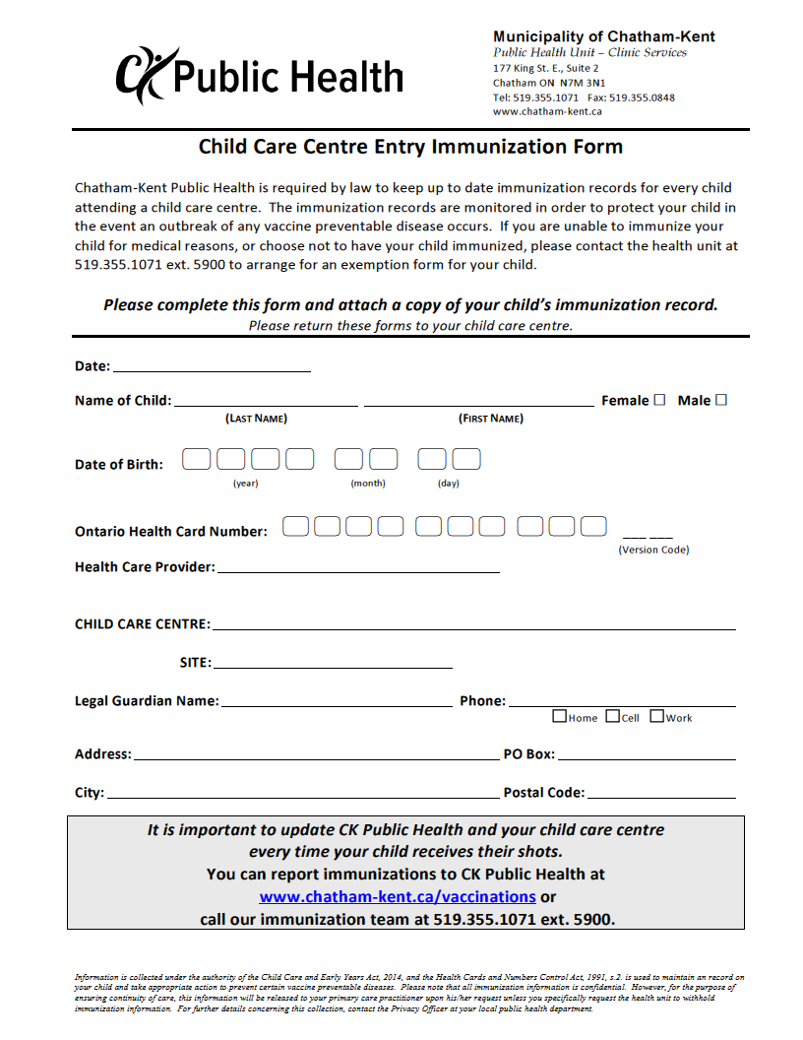

**Emergency Information Sheet**

Child Information

|  |  |  |
| --- | --- | --- |
| **Full Legal Name:** | | **Date of Birth:** |
| **Home Address:** | | |
| **Health Card Number:** | **Allergy:** | |
| **Doctor’s Name, Address and Phone Number:** | **Medical and/or Other Information:** | |

Parent/Guardian Information

|  |  |  |
| --- | --- | --- |
| **Full Legal Name:** | | **Relationship to Child:** |
| **Home Address:**  □ Same as Child | | |
| **Primary Phone Number:** | **Email address:** | |
| **Place and Address of Employment:** | | **Work Phone Number:** |

|  |  |  |
| --- | --- | --- |
| **Full Legal Name:** | | **Relationship to Child:** |
| **Home Address:**  □ Same as Child | | |
| **Primary Phone Number:** | **Email address:** | |
| **Place and Address of Employment:** | | **Employment Phone Number:** |

Emergency Contacts Pick Up Authorization

|  |  |
| --- | --- |
| Emergency Contact #1 | Pick Up Authorization #1 |
| Full Legal Name:  Phone Number:  □ Authorized to pick-up child | Full Legal Name:  Phone Number: |
| **Emergency Contact #2** | **Pick Up Authorization #2** |
| Full Legal Name:  Phone Number:  □ Authorized to pick-up child | Full Legal Name:  Phone Number |