Hello Parents,
TTELC is thrilled to share with you that we are using the exciting and interactive program called HiMama!

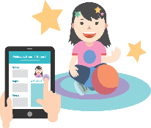What is the HiMama program?
HiMama will be used by TTELC educators to record activities and to document updates throughout your child’s day. Everything from naps to snacks, it will provide you with a complete history of your child's experience in our program.

What does this mean for me?
Whether it be at work, home or on the go, HiMama will keep you in the loop with real-time updates on your child’s activities to complement our important face-to-face interactions. It is also a great way to reinforce your child’s in-program learning at home, as you’ll have timely insight through your email or smartphone into what they've been working on throughout the day!

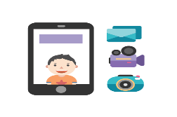Is there anything I have to do?
You can download “HiMama – The Childcare App”. Check your email inbox, an invitation will be sent to you. At that point you can create an account. If you want to share updates with additional family members, you can also do so once you’ve created an account.oWan tm!
o le Want to learn more!? Visit www.himama.com.n more? Visit www.himama.com!vearn more? Visit www.himama.com!

